Flux Capacitor LED Badge - GitHub: <https://github.com/slash128v6/DC30_CNet_Badge>

One of the 4 small LEDs is a fast-cycling LED. These LEDs have internal currently limiting resistors so you can test by connecting it to the battery pack as shown with the longer lead to the left. Do not test regular LEDs like this, they will fry. Set aside the fast-cycling LED. The other 3 are slow-cycling LEDs.

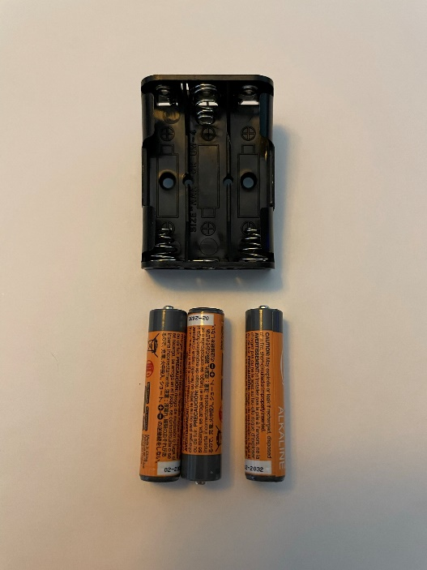 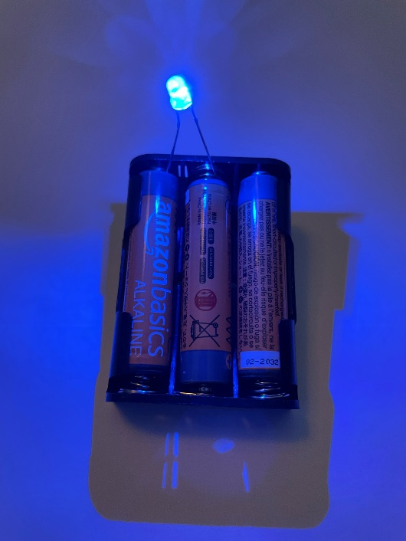

Solder 2 of the slow-cycling rear LEDs on the back with short lead and flat facing label LED1 & LED2. Bend the LEDs so they are flat against the back of the board to shine through the translucent area on the PCB. Solder R1 on the back. Trim the leads on the front.

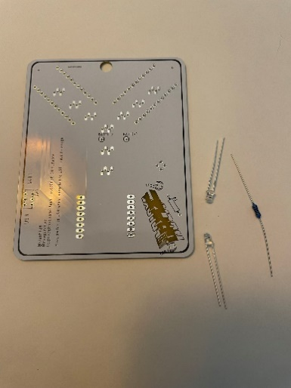 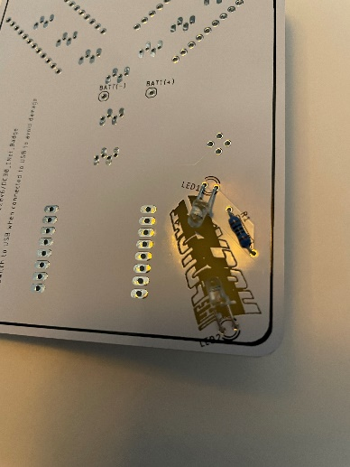 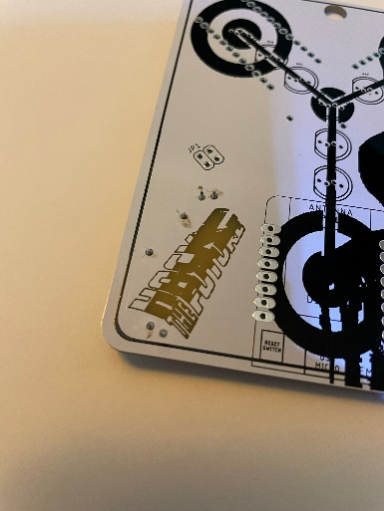

Solder the switch on the back.

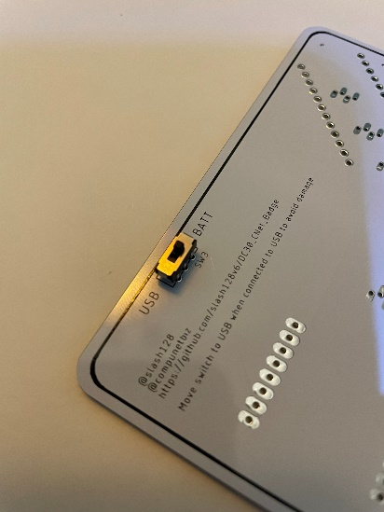 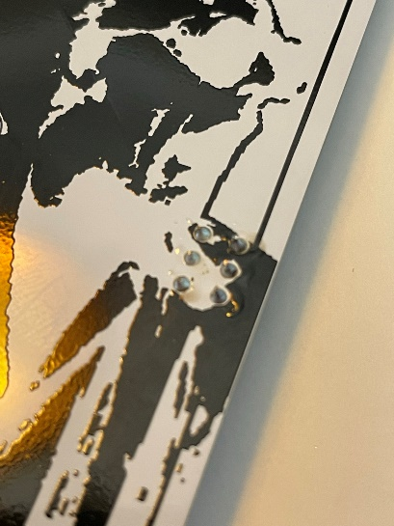

Solder the SAO 4 pin female header on the front.

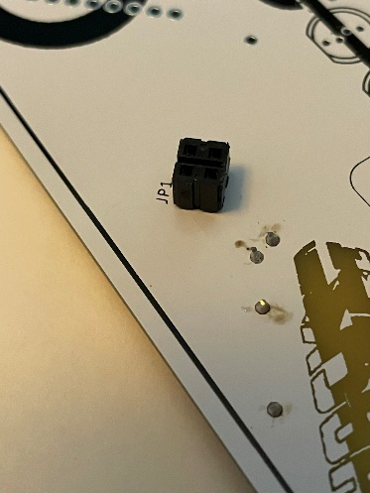 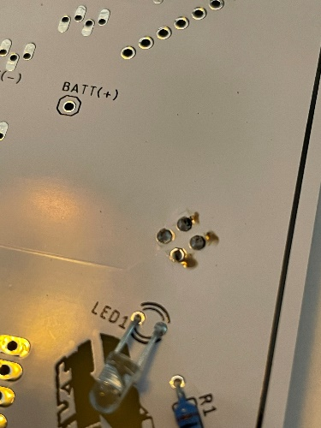

Install front RGB LEDs with long leads and flat on the left, matching the symbol on the board. Do not push all the way in, stop at the marks on the leads. Make sure there are no solder bridges. Trim the leads so there is clearance for the micro controllers to install on the other side.

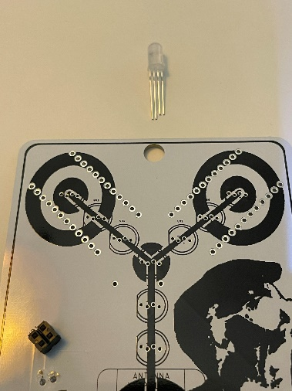 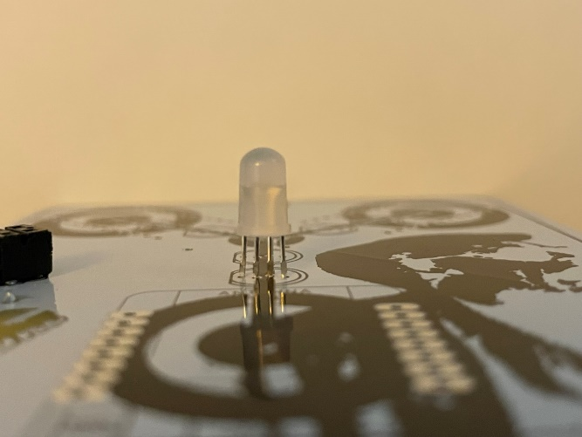

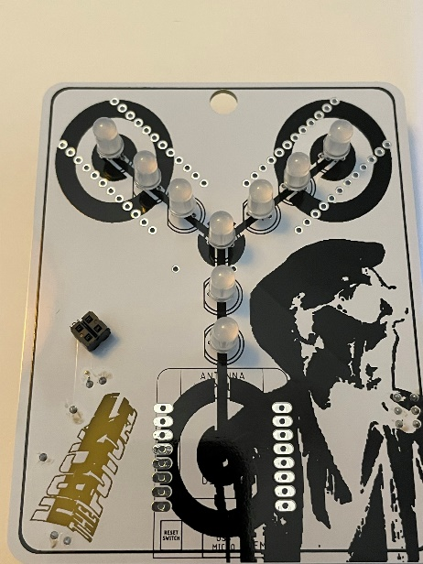 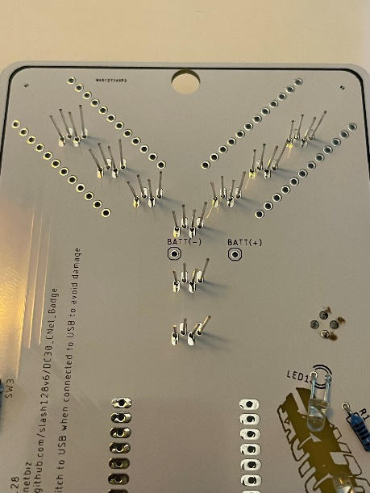 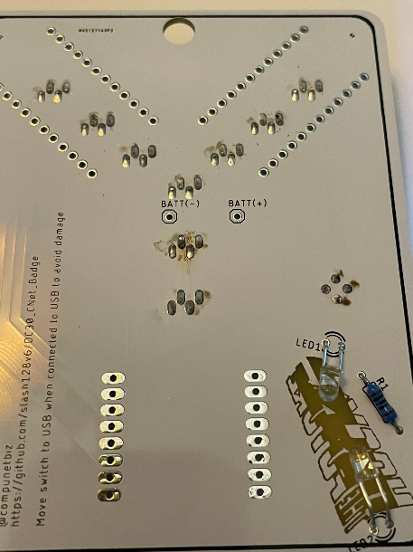

Rear View – WiFi Duck Pro Micro is on the left, LED Pro Micro is on the right. Install with USB connector at the top and facing up away from the board. Install headers with long side facing away from the badge, black insulator between the micro and badge board. Make sure to solder all the pins on both the badge board and micro board.

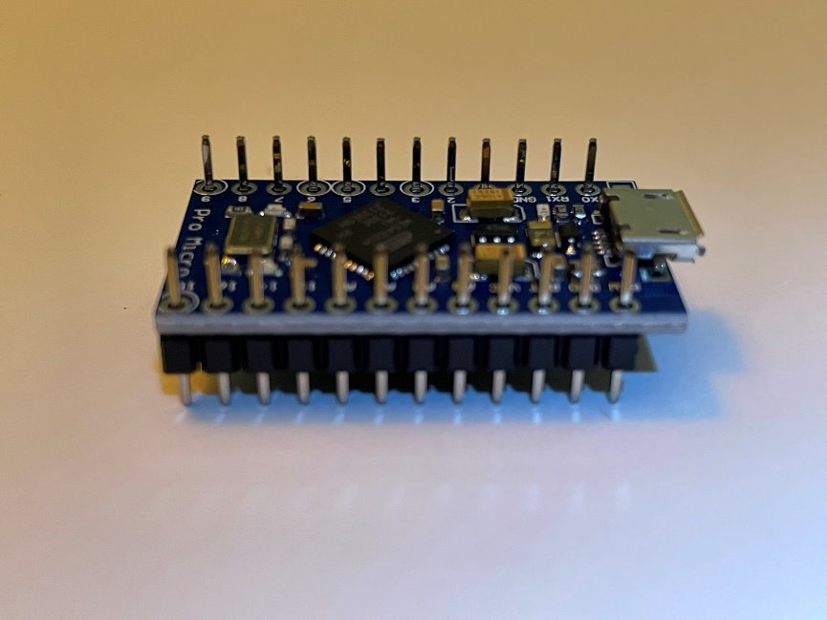 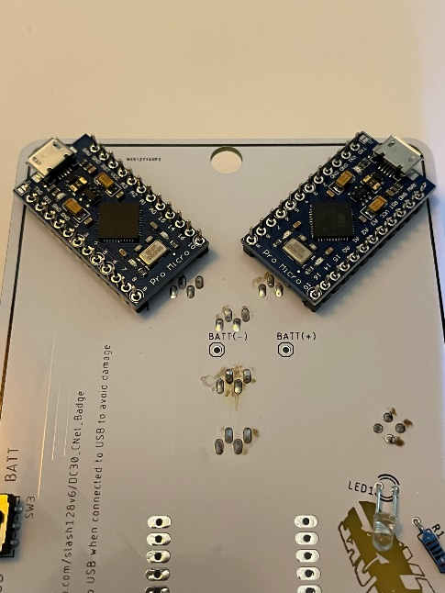

Front View – D1 Mini. Install with reset button on the left and USB connector at the bottom facing down towards the board. Install headers with long side facing away from the badge, black insulator between the micro and badge board.

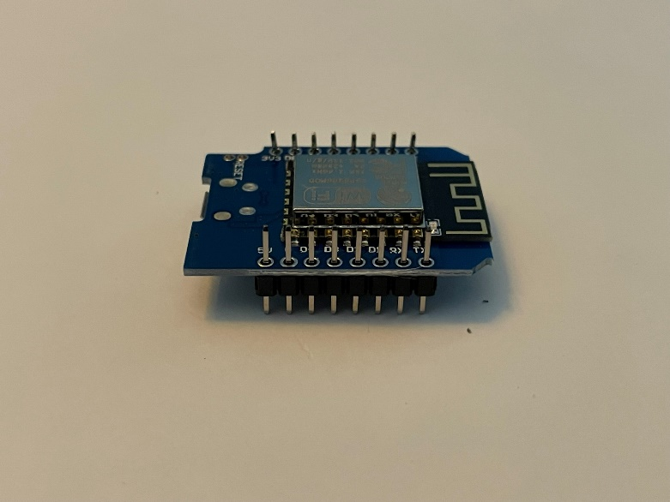 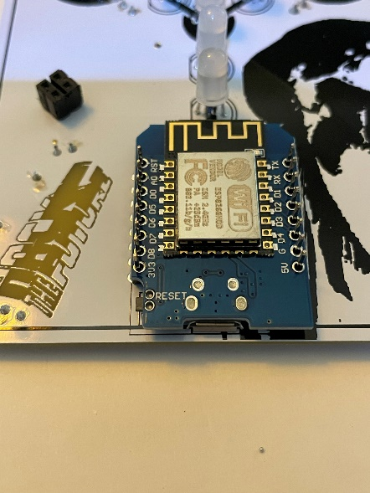

Trim a piece of double-sided foam tape to fit between the pins of the D1 Mini on back, then place battery holder on tape and solder the leads on the front

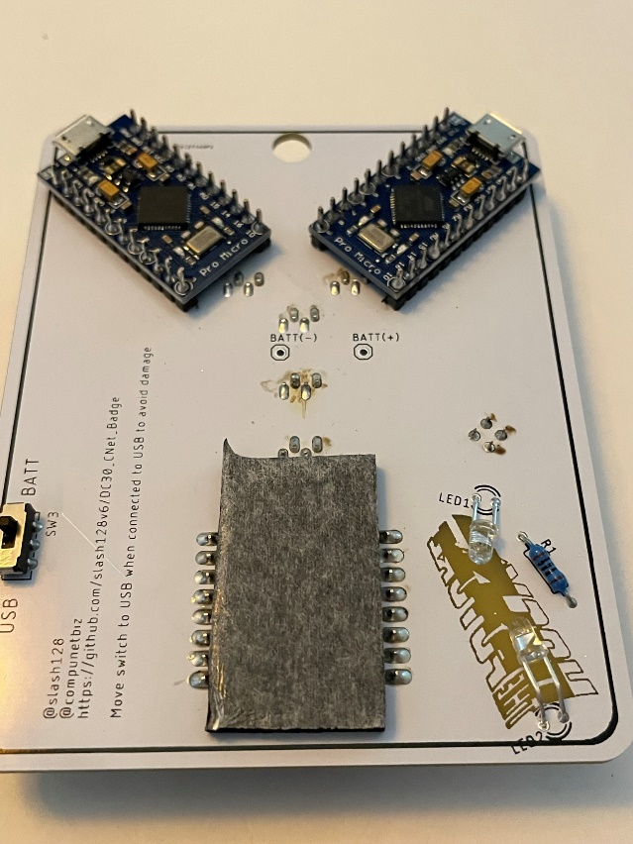 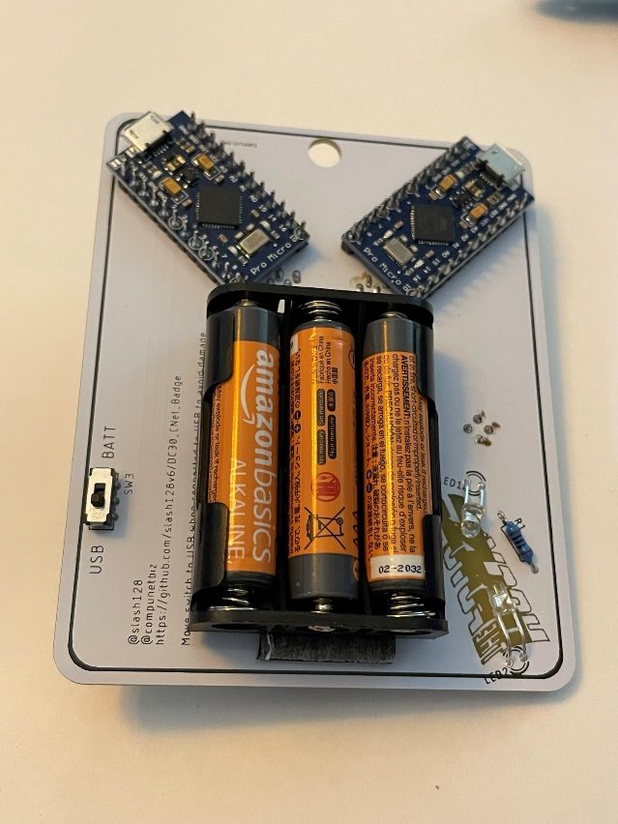

Slide switch to BATT for battery mode and USB when connecting to USB. Do not leave switch in BATT mode when USB power is connected.

SAO

Solder rear LEDs on the back with short lead and flat facing label LED1 & LED2. Bend the LEDs so they are flat against the back of the board to shine through the clear area on the PCB. The fast-cycling LED goes behind the surfing cow and the slow cycling LED goes behind the sun. Solder R1 on the back. Solder the male 4 pin header on the back. Trim the LED and resistor excess leads on the front.

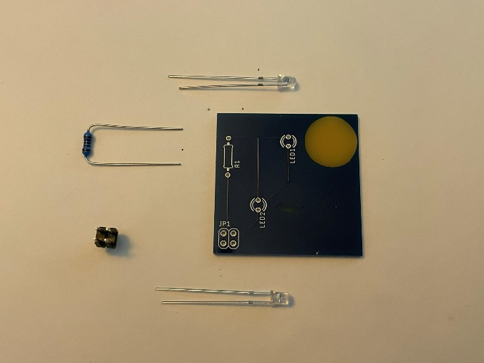 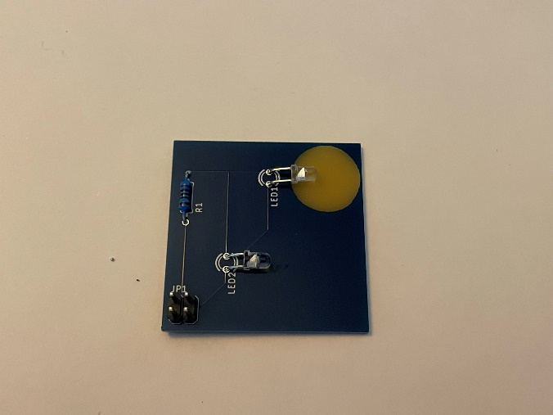 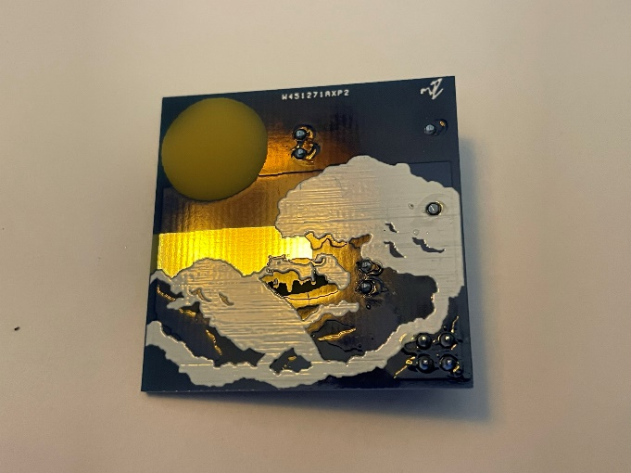

Connect the SAO PCB to the main badge. Slide the switch to BATT and verify the small LEDs on the main badge and SAO all work.

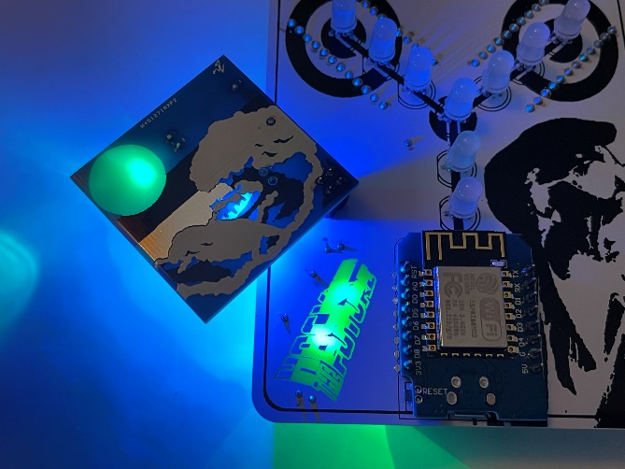 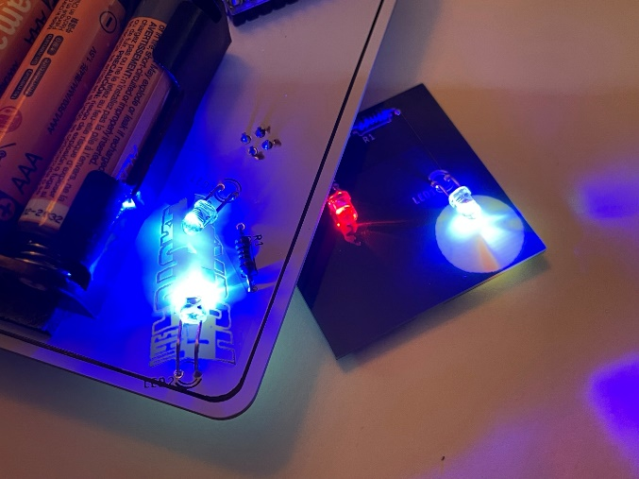

Badge LED Micro Programming

Load the SparkFun Pro Micro board in Board Manager in the Arduino IDE:

<https://www.sparkfun.com/products/12640>

Connect a data micro USB cable to the right Pro Micro on the back of the badge.

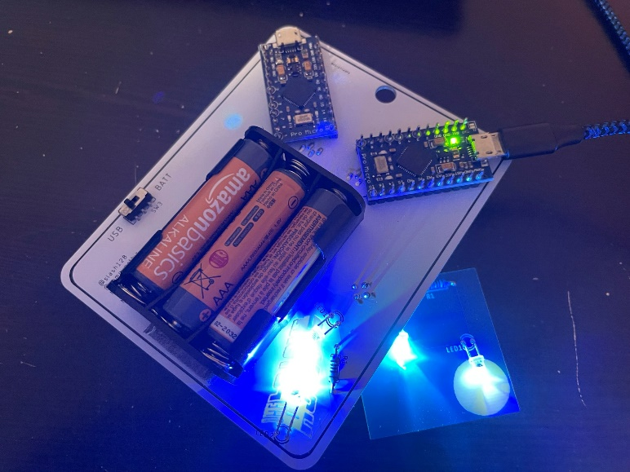

Download the LED Micro .ino file from the repo and open in Arduino: <https://github.com/slash128v6/DC30_CNet_Badge/blob/main/DC30_CNet_Badge/DC30_CNet_Badge.ino>

Make sure you select the SparkFun Pro Micro from the SparkFun boards and Processor is the 5V, 16MHz version. If you select the 3V version and try to upload you’ll have to follow the recover process from SparkFun to unbrick it.

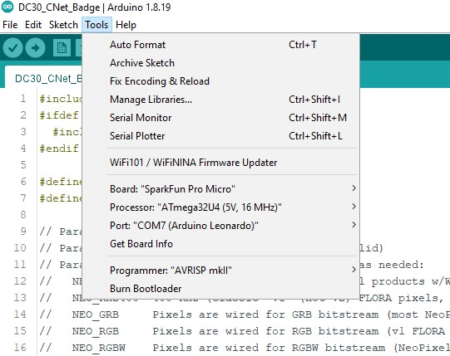

Once you have all your settings correct and port selected upload the file and then the LEDs on the front should start cycling. The front center RGB LED is for the WiFi Duck and does not light up with the other LEDs. See the WiFi Duck scripting documentation for use.

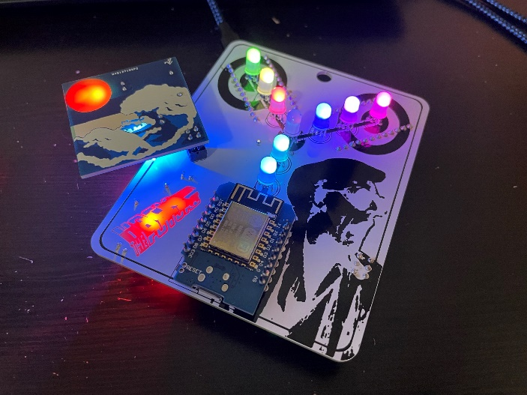

WiFi Duck

The front center RGB LED is for the WiFi Duck and does not light up with the other LEDs. See the WiFi Duck scripting documentation for use.

The WiFi Duck uses the D1 Mini on the front and the Pro Micro on the back left side.

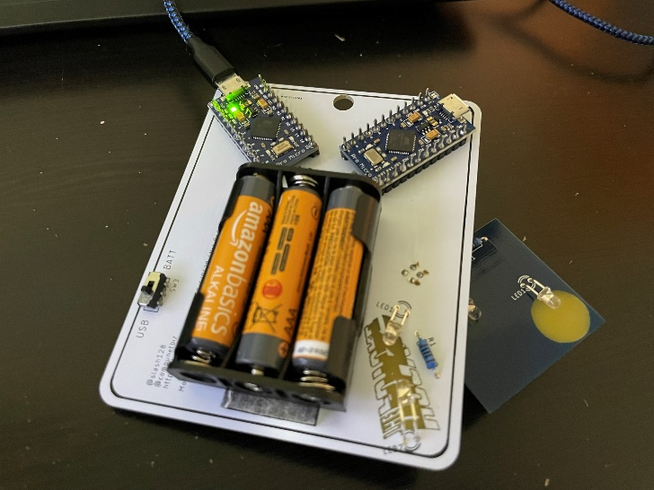 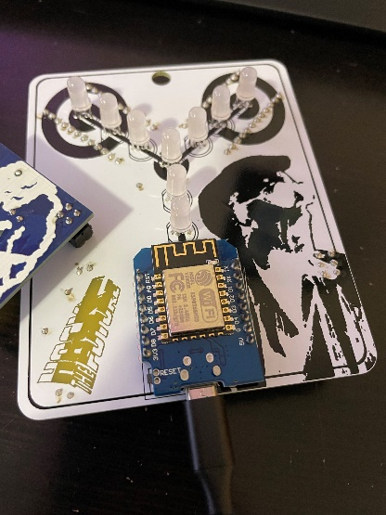

Follow the guide on the WiFi Duck GitHub for uploading firmware: <https://github.com/SpacehuhnTech/WiFiDuck>

Make sure to use the correct board settings from the WiFi Duck boards and also make sure Debug is Disabled and Protocol is set to I2C for both the WiFi AVR Micro and D1 Mini. Neopixel on Pin 7.

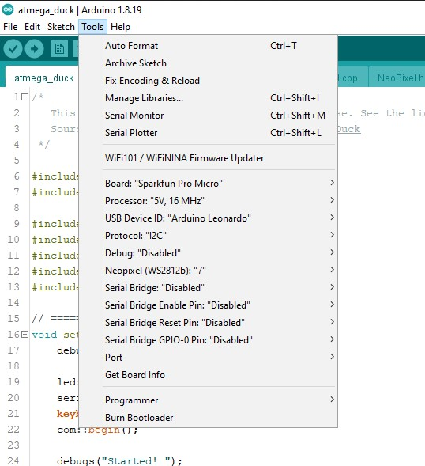 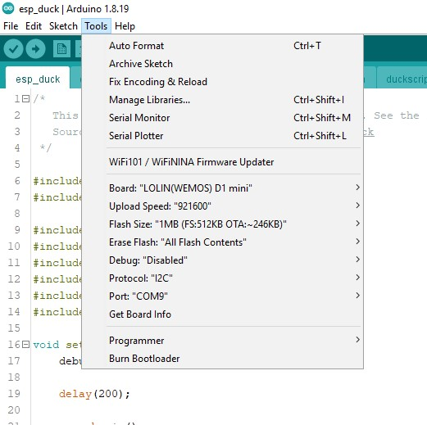

With the WiFi Duck powered by USB (either D1 Miini or Pro Micro) connect to WiFi network “wifiduck” with password “wifiduck” and open a browser window to <http://192.168.4.1>. Create a script called rickroll.script.

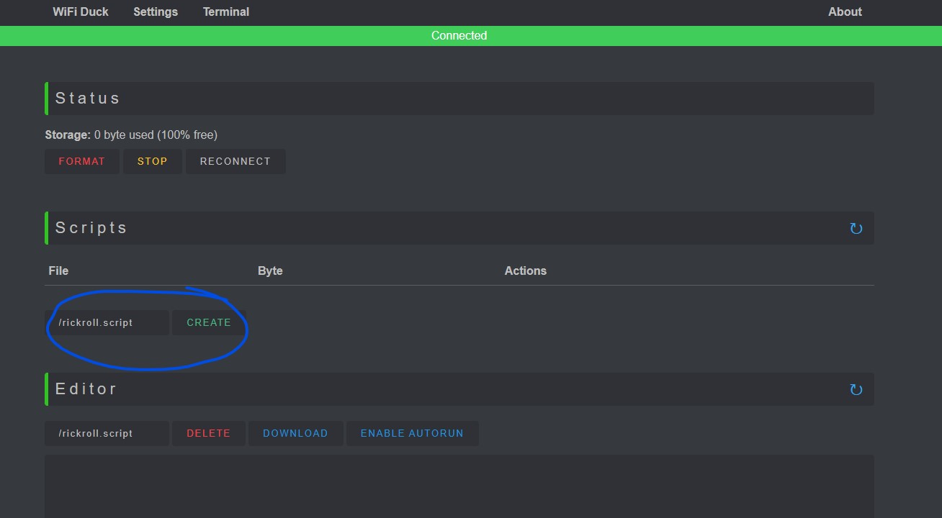

Paste the contents of rickroll.script file into the Editor, click Save and Enable Autorun.

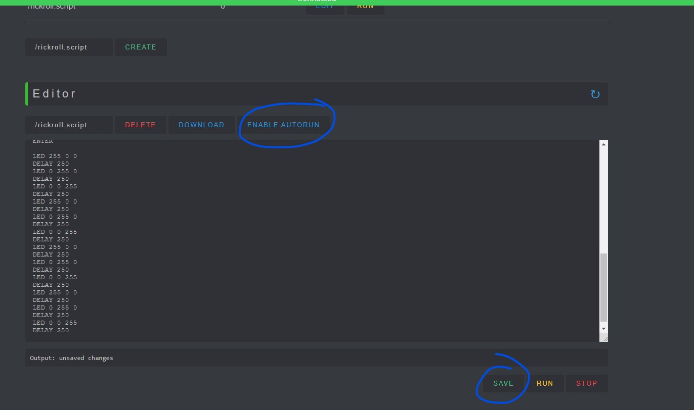

With the USB cable connected to your PC and the WiFi Duck AVR Micro click the Run button and the script should run. With Autorun enabled the script should autorun when the USB connection is made.

